Infotip – Encrypting USB Drives for OSX

Use this InfoTip to set up encryption on mobile USB storage devices eg. USB stick. Create a few of them so they are handy.

Prerequisites:

- USB drives that have been encrypted for OSX are NOT backwards compatible. If you try to use an encrypted USB in an older version of OSX the drive will NOT be readable.
- Encrypted drives are NOT cross platform. A USB drive encrypted using OSX will not work on a Windows machine.

Recommendation:
- USB drives are not recommended to be used as a backup drive for file storage. They should be used to transport files only. Please use a proper backup application if you need to backup and store files.

Setup Procedure

- Insert a blank USB device to an OSX computer
- Open the Disk Utility application (command + space will open up Spotlight and allow you to search)
- Select the USB drive on the left-hand side
- Click the Erase menu button at the top of the Disk Utility window

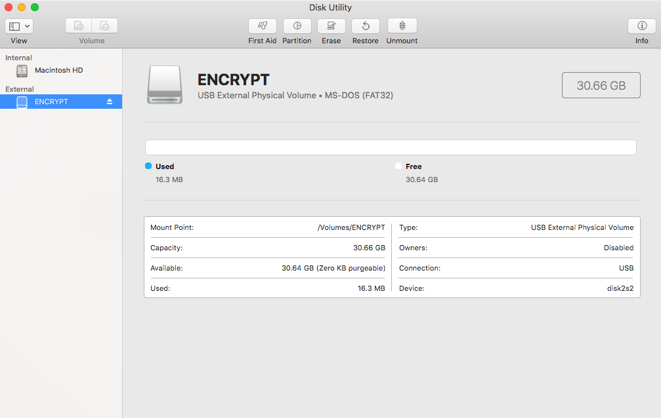

- Select “Mac OS Extended (Journaled, Encrypted)”

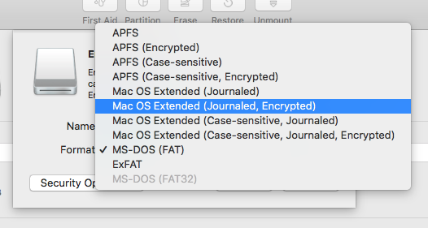

- You will be prompted to choose a password. Pick a strong password: at least 12 characters and use upper and lower letters, numbers and special characters.

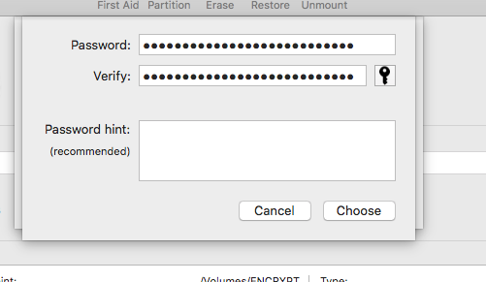

- Do not forget this password. If you do, you will need to re-format the USB drive in order to use it again. Any files that are on the USB drive when you format it will be lost.
- Store your password. We recommend using a password manager application to ensure you don’t lose your passwords.

Using Your Encrypted USB Device
- Once the device is set up, it can be used with any OSX computer running the same version of the operating system as a regular storage device once you use the password with the device, ie. you can copy/delete/move files on the device.
- If you forget the password, the encrypted data is not recoverable IF YOU LOSE/FORGET THE PASSWORD, THE ENCRYPTED DATA IS NOT RECOVERABLE. The use of a password manager is highly recommended.
- To un-encrypt an encrypted device, re-format it as described above.

