Infotip – Password Manager

Why use a password manager?

Using a password manager allows you to store all your login credentials in a single place and retrieve them easily when needed.

This allows you to create a unique set of credentials for every application/website that you need to – instead of using the same credentials for all of them. If you do use the same password for all your logins, and that password is exposed, then an attacker could log into all the accounts you use that password for.

Recommended password manager: KeepassXC

KeePassXC is:
- Open source
- Works on all platforms (including iOS, Android and a portable version for USB drives)
- Free

KeePassXC is installed on your workstation, and keeps your login credentials on your desktop/laptop/device where you installed the application. It creates a database which allows you to create separate entries for each application/website that you log into and saves both the username and the password for that entry.

It requires a master password to access the database where your passwords are stored. Do not forget the master password, or you will not be able to access the database and you will lose access to all your saved entries.

There is an option to use a key file as your entry to the database instead of password. There’s also an option to use both the master password and the key file if you desire this additional layer of security.

Also, please be aware that KeePassXC does NOT capture login credentials as they are created. Instead, you will need enter that information manually. It is a good idea to create that entry immediately after you create a new login.

Download installation files here: https://keepass.info/download.html

Setup steps:

- Download and run the installer for your specific operating system or device (You may need Administrator privileges to install this) and follow the installation instructions.
- Once installed, open KeePass
- Click on File > New
- The new database window will popup. This is where you create your master password and/or a key file.
  - Master Password: This is the one password you must remember. If you forgot or lose this password, there is no way to change it and you will lose access to your database of saved login credentials.
  - Master Key File: This step is optional but if desired you can create a master key. You will need this master key as well as the master password to access your database of saved login credentials. Please note: if you lose or delete the master key file you will lose access to your database of save login credentials.
  - Windows user account: this is recommended for advanced users only.

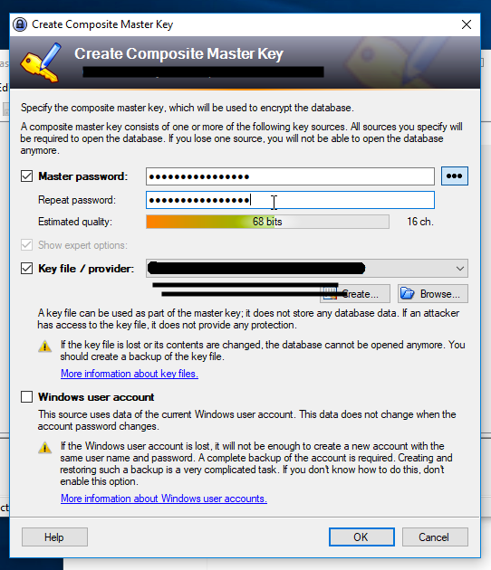

- Once you have configured and created your master password (and key file if you chose) the login database window will open. If you wish to set up advanced options for your database this is where you can do that. This is recommended for advanced users only. When ready to continue, hit OK.
- Your new database should look something like this:

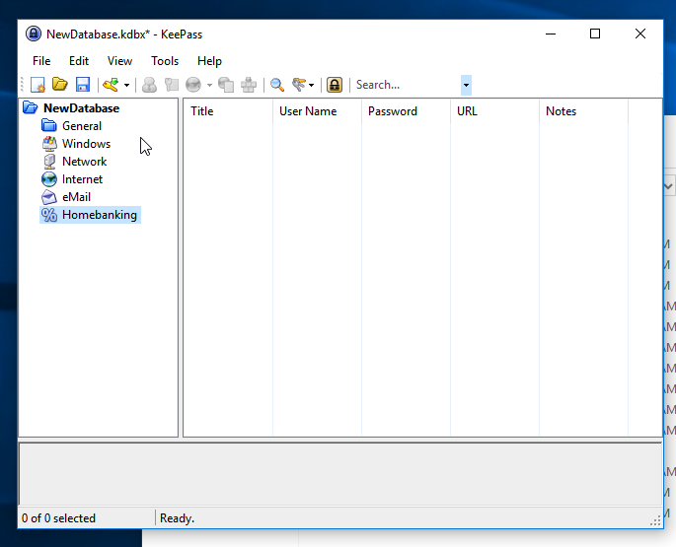

- To create an entry, click on the key icon, which will bring up the Add Entry window:

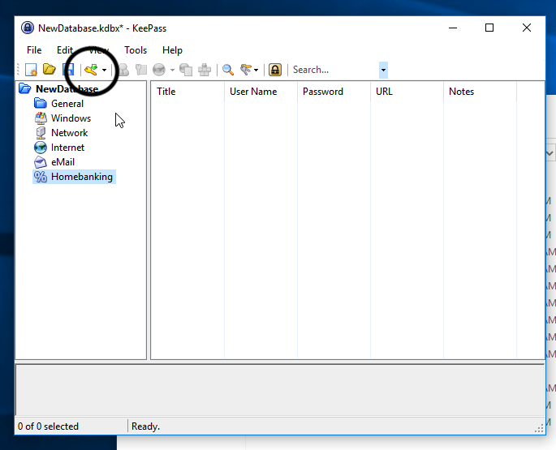

- Create the entry by filling in your username and password. Make sure to give the entry a title. Save the entry by clicking OK.
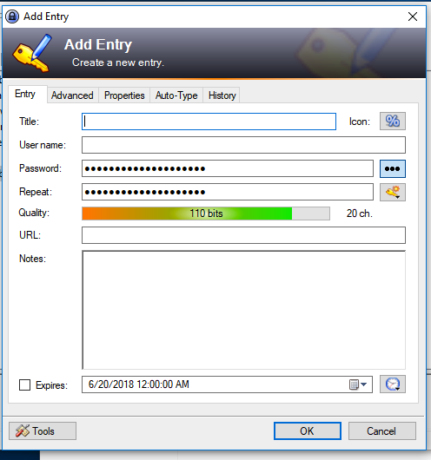

- The add entry window will close and the new entry should be displayed in the database list.

